
Individual Assignment (Final Project)
UCI Seeds (Artificial Neural Network)

By
Teddy Fabrizio Baeny Vargas (NF1005996)

Master of Data Analytics
University of Niagara Falls
Machine Learning (CPSC-640-8)
Professor: William Pourmajidi
December 7th, 2025

ASSIGNMENT DESCRIPTION
This individual assignment consists of designing, training, and evaluating a feed-forward artificial neural network (ANN) using a structured dataset with 210 samples, seven numerical features, and three output classes. The goal is to understand how each machine learning step contributes to the final model performance, and to interpret the results in a meaningful way that generate valuable insights.
SECTION 1 – DATA LOADING AND EXPLORATORY DATA ANALYSIS
This first section loaded the dataset and identified the different columns or features it has. The eight columns are: Area, Perimeter, Compactness, Length of Kernel, Width of Kernel, Asymmetry Coefficient, Length of Kernel Groove, and Class. This last column is the most essential as it contains the 3 classes of the wheat types that the dataset contains. The three classes are: Kama, Rosa, Canadian. These 3 classes are all balanced in the dataset as there are 70 rows that belong to each category.
To further understand the dataset, a distribution graph with boxplot was made for all classes and a correlation matrix as well. The distribution shows that all classes have similar distributions and overlap each other, but with enough space to recognize one from each other. While the correlation heatmap shows the high positive correlation between all features and only asymmetry coefficient has a low negative correlation value with the other variables, which indicates feature redundancy in the dataset.
SECTION 2 – PREPROCESSING
The code made here handled missing data checks which doesn’t exist in the dataset. Also, it prepares the data for the ANN model later by splitting the data into two: Training (80%) and Test (20%). The code stratifies the data, so all classes are represented equally in both partitions. Finally, a standard scaling was done because neural networks perform significantly better when input features share similar scales. Without normalization, certain features may dominate gradient calculations, slow convergence or leading to unstable training.
SECTION 3 – ANN DESIGN AND TRAINING
The model selected for this assignment is a multi-layer perceptron (MLP) using TensorFlow/Keras with the following architecture:
- Input layer: 7 features
- Hidden layer 1: 64 units, ReLU, Dropout 0.4
- Hidden layer 2: 32 units, ReLU, Dropout 0.4
- Output layer: 3 units + softmax
- Optimizer: Adam (learning rate = 0.001)
- Loss: sparse_categorical_crossentropy (labels are 0, 1, 2 for the 3 wheat classes)
- Regularization: Dropout (chosen over L2 for its simplicity and strong performance on small datasets)
- Training: 100 epochs + EarlyStopping to avoid unnecessary computation
After running for 71 epochs and dividing the training data into two in order to validate the model. The results for the training appear in two graphs for accuracy and loss for both validations. The left graph shows a comparison of training and validation accuracy where the training value increased and surpassed the validation value as more epochs ran, but never where both have very different accuracy scores. The same pattern repeats in the loss value and in the end the accuracy and loss for validation is 0.9412 and 0.1617 respectively which is a good result and means that the ANN architecture works here.
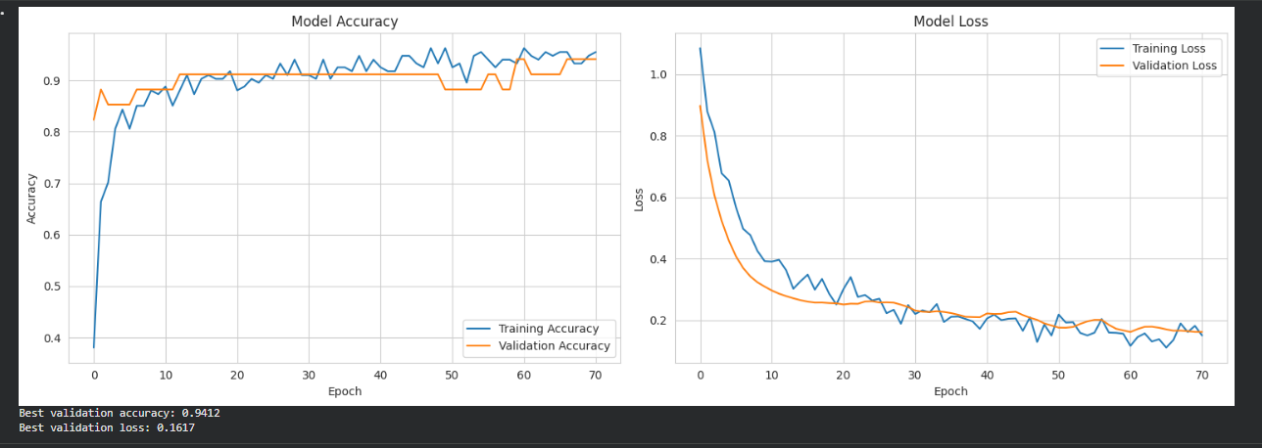
SECTION 4 – HYPERPARAMETER COMPARISON
For this section a hyperparameter modification is made in the dropout rate which was 0.4 for the original model. Therefore, two new models are created:
- Model A: Dropout = 0.2 (light regularization)
- Model B: Dropout = 0.5 (strong regularization)
The outcomes from these models give very interesting insights where the Light Regularization (Dropout 0.2) performs better than the Strong Regularization (Dropout 0.5) where the Light model’s accuracy is higher at 0.9706 and its loss is lower at 0.1355 than the accuracy (0.9118) and loss (0.1656) of the Strong Model. Moreover, the graph below shows that the Smaller Dropout model takes more epochs to run which improves its metrics.
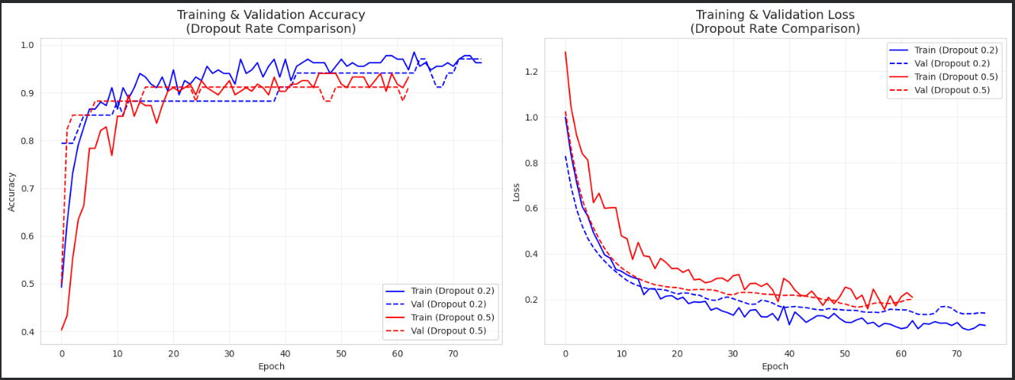
SECTION 5 – FINAL EVALUATION
The final section includes a comparison of both Strong and Light Regularization models with the test data created in Section 2. The results from this comparison show than similar to the previous section the Light Regularization model performs better as it gets an accuracy of 88,10% compared to the value of 85.71% of the Strong model. Also, as seen below the Dropout 0.2 model has better numbers in all evaluation metrics for the 3 classes showing this hyperparameter change resulted in a more precise model.
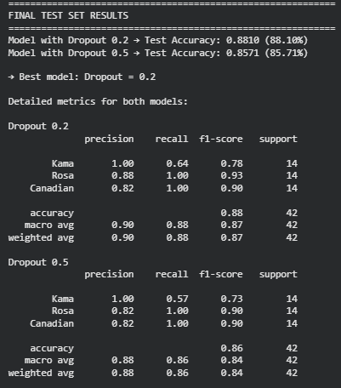
Finally, a confusion matrix was made for the Light Regularization model where this model was able to successfully categorize data as Rosa and Canadian with no error. However, Kama has 5 misclassifications and 9 correct predictions. This suggests that the Kama class shares morphological similarities with the other wheat varieties, making it harder for the model to separate. This is consistent with the EDA finding that class distributions overlap, and Kama appears to sit between Rosa and Canadian in several feature dimensions.
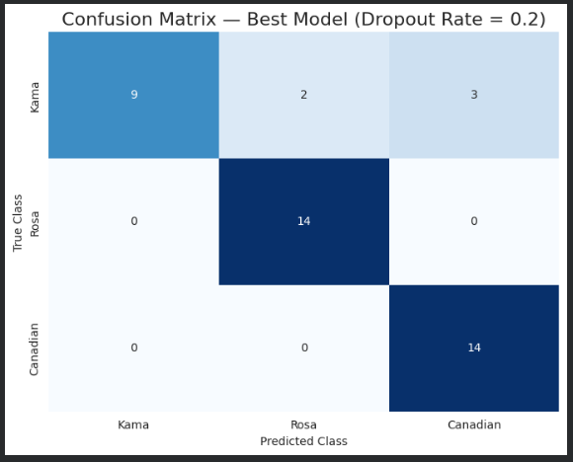
FINAL CONCLUSIONS
The feed-forward artificial neural network developed in this project successfully classified wheat varieties from the UCI Seeds dataset, achieving a final test accuracy of 88.10% with the best-performing model (Dropout = 0.2). Across all five sections — data loading, preprocessing, model design, hyperparameter comparison, and final evaluation — the project confirmed that a well-designed ANN can learn meaningful patterns from small, balanced datasets with only seven features.
Key insights include:
- Normalization significantly contributed to stable and efficient learning. Without StandardScaler, features with larger magnitudes such as area and perimeter would dominate gradient updates, slowing convergence and potentially preventing the model from learning the contribution of smaller-scale features like asymmetry coefficient.
- The perfectly balanced class distribution (70 samples per class) made evaluation straightforward and reliable. No class weighting was needed, and metrics like precision, recall and F1-score could be interpreted without adjustments for imbalance, which is often a major complication in real-world classification problems.
- The ANN architecture (64 → 32 units, ReLU, Dropout, softmax output) was appropriate for the complexity of the dataset. The two-layer design had enough capacity to learn non-linear boundaries between classes without being so large that it would overfit on just 168 training samples. The hyperparameter comparison confirmed this: Dropout = 0.2 outperformed Dropout = 0.5 because the dataset is small and clean enough that heavy regularization suppresses useful signal rather than just noise.
- Evaluation metrics confirmed strong generalization rather than memorization. The validation accuracy of 0.9706 and loss of 0.1355 for the best model, combined with a test accuracy of 88.10%, show that the gap between training and test performance is small. Rosa and Canadian were classified with no errors, while Kama was the only class with misclassifications — a result consistent with the overlap observed in the EDA distributions.
Future improvements could include testing deeper architectures with three or more hidden layers to see whether additional capacity improves Kama classification without overfitting. A systematic hyperparameter search using Keras Tuner or GridSearchCV across learning rate, batch size, and number of units would be more comprehensive than the manual dropout comparison done here. Comparing the ANN against classical ML models such as SVM, Random Forest, or k-NN on the same dataset would also provide useful context on whether the neural network is the right tool for this problem size. Finally, applying dimensionality reduction such as PCA before training could help assess whether the high inter-feature correlation identified in the EDA impacts model performance.

